**PHASE 4 - Process Automation (Admin)**

The goal of this phase is to use Salesforce's declarative tools to automate the core business logic, enforce data quality, and handle notifications.

**➡️ Validation Rules**

Validation rules are created to ensure the data entered by users is accurate before it is saved.

* **Object**: Order__c
* **Rule**: To ensure the Total_Amount__c is a positive number.
* **Formula**: Total_Amount__c <= 0
* **Error Message**: "The Total Amount must be greater than zero."

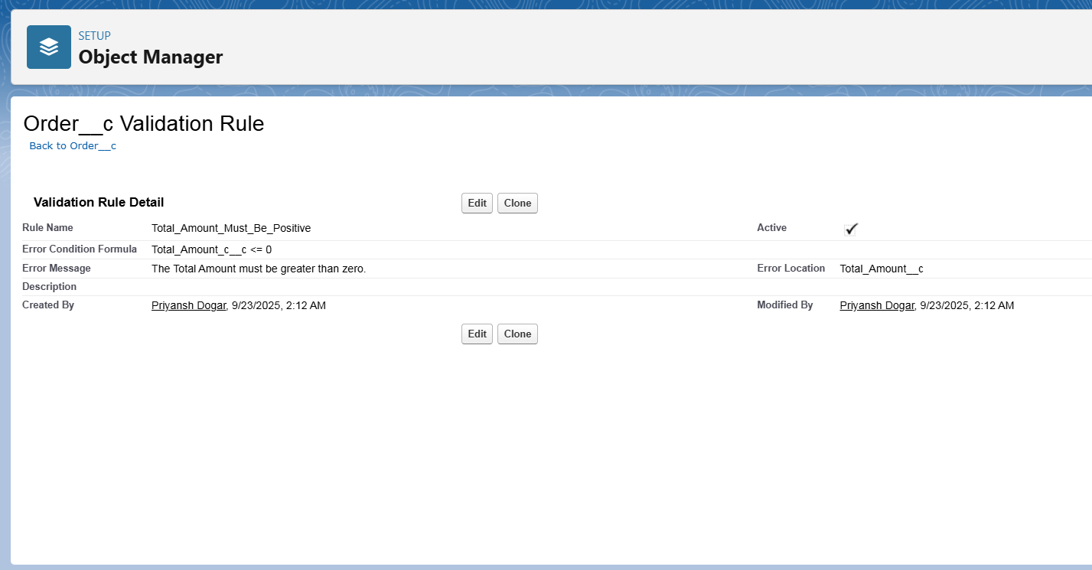

**➡️ Flow Builder (Record-Triggered Flow)**

As the primary automation tool, Flow Builder was used to implement the core loyalty points logic. A record-triggered flow named "Update Loyalty Points on Order Completion" was built.

* **Objective**: To automatically find a customer's loyalty record and add points to it when their order is finalized.
* **Flow Type**: Record-Triggered Flow.
* **Trigger Configuration**: The flow is configured to run *after* an **Order__c** record is **created or updated** and the **Status__c** field **Equals 'Complete'**.
* **Flow Logic**:
  1. **Get Records**: The flow first finds the related Loyalty_Program__c record where its Customer__c field matches the Customer__c on the order that triggered the flow.

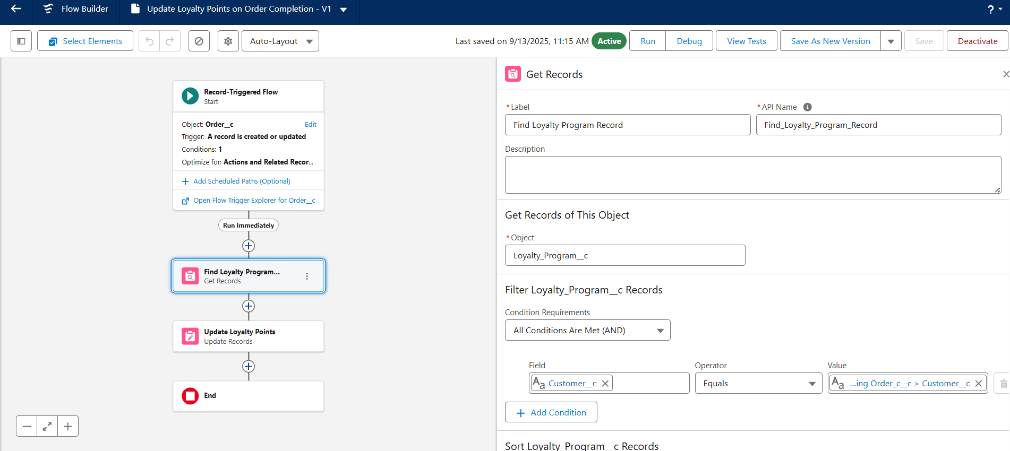

* 1. **Update Records (Field Updates)**: The flow then updates the Points_Balance__c field on the loyalty record. It uses a formula to add the new points (Total_Amount__c * 0.1) to the existing balance.

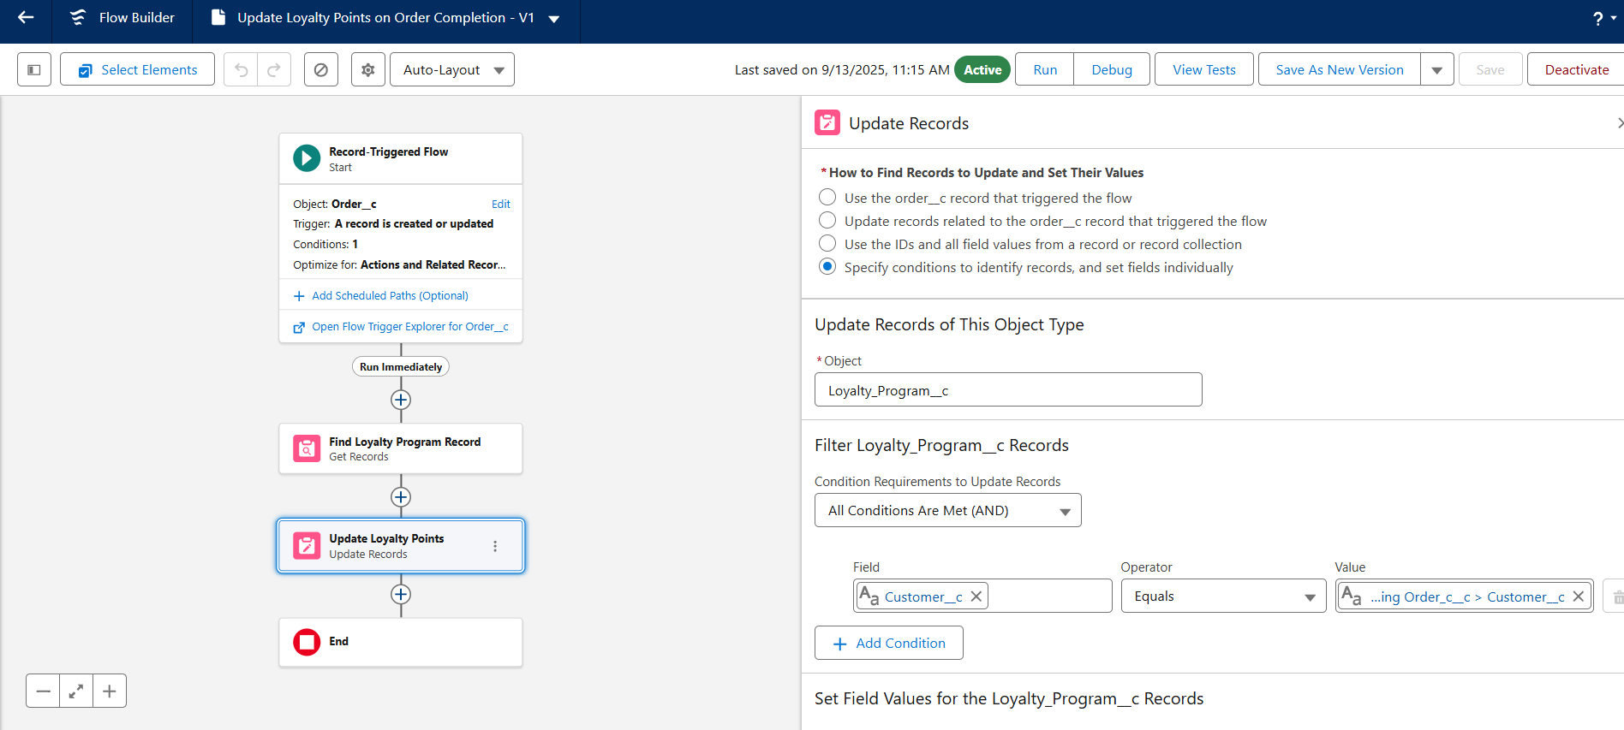

* **Activation**: The flow is saved and activated to run automatically whenever the criteria are met.

**➡️ Approval Process**

An approval process automates how records are approved. **While not part of the initial build, a potential future use case has been identified**:

* **Objective**: Require a manager's approval for any Order__c with a Total_Amount__c exceeding a certain value (e.g., 5,000 INR).
* **Process**: An order meeting the criteria would be automatically submitted to the user's manager for approval or rejection, updating the order's status accordingly.

**➡️ Workflow Rules & Process Builder**

These are legacy automation tools in Salesforce. For this project, all new automation, including the loyalty points calculation, was built using **Flow Builder** to align with current Salesforce best practices.